**Title: The uneven distribution of homicides in Brazil and their effect on life expectancy, 2000-15**

**(Aim: Health Affairs, AJPH,…)**

**Authors:** José Manuel Aburtoa,b, Júlia Calazansc, Bernardo L. Queirozc, Shammi Luhard & Vladimir Canudas-Romoe

**Author affiliations:**

a Interdisciplinary Center on Population Dynamics, University of Southern Denmark.

b Max Planck Institute for Demographic Research, Rostock, Germany.

b CEDEPLAR, Universidade Federal de Minas Gerais, Belo Horizonte, Brazil.

c London School of Hygiene and Tropical Medicine.

d School of Demography, Australian National University.

**Corresponding author:**

José Manuel Aburto

Email: jmaburto@sdu.dk

Tel. number: +45 65 50 94 16

Address: J.B. Winsløws Vej 9. DK-5000 Odense C, Denmark.

**Classification:** Violence, Population Health and Demography

**Keywords:** violence, demography, health inequality, avoidable/amenable mortality.

**Abstract [Max 150 words]:**

**\maintext[max 4800 words including references]**

**Introduction [450 words]**

Recent increases in homicide in Latin America may be jeopardizing population health gains,1-3 brought about by efforts towards universal health coverage4 and reductions in health-related financial insecurity in the past half a century.2

Between 1960 and 2015, life expectancy in Brazil increased from 54.2 to 74.7 years, converging with many developed countries.5 Reductions in amenable mortality have contributed to these gains, in particular, infant and cardiovascular disease mortality,6-10 and has coincided with the introduction of a mandated universal healthcare system in the past three decades.11-14 Including since 1988 the Unified Health System 1994 (Sistema Único de Saúde), and the subsequent Family Health Program which has led to substantial benefits.12 15

Violence and homicides, however, present a major public health concern in Latin America.16 In Brazil specifically, homicides are the third leading cause of death with accidents for the total population and the main cause of death among young adults.17 18 Between 2000 and 2007, the homicide rate was 23 per 100,000 people, a rate considerably higher than most neighboring countries.16 Currently, the homicide risk is ten times higher than in most developed countries.18

Although informative for the purpose of cross-country comparisons, national statistics for Brazil mask large disparities subnationally, and between females and males. For instance, life expectancy ranged from 63.2 years in Alagoas to 71.3 in Santa Catarina in 2000,19 and the rate of change in life expectancy in recent years has varied from 0.6 to 4.1 years between Southeast and Northeast regions,20 respectively. A large contributory factor may be inequality in amenable mortality reductions in 2000-12, which varied between 11% and 4.3% in states with high and low governance scores, respectively.6

Further complicating our understanding of Brazil’s mortality experience is the variation in homicide rates between men and women.16 21 High homicide rates have the potential to reverse life expectancy gains, as was recently reported in the contexts of Mexico and Venezuela,22-24 and homicide rates among Brazilian men are ten times that of women.16 Although national statistics do not indicate any change in homicide rates in the last decade,25 this could be due to the balancing effect of homicide rates increasing in some states while decreasing in others. For instance, whilst the homicide rate has declined in Brasilia between 2007 and 2011, in the same period, homicides have increased by more than 40% in Bahia.26

Despite the considerable inter-gender and subnational variation in mortality and homicides in Brazil, studies examining the contributing effect of homicide mortality to changes in life expectancy are scarce. This paper aims to examine the effect of homicide mortality on changes in state-level life expectancy in the new century, in order to inform public health planning aiming to reduce the burden of violence and health disparities in Brazil.

**Study Data and Methods [800 including limitations]**

We obtained state-level mortality data by age, sex, year and causes of death from the Mortality Information System produced by the Brazilian Ministry of Health.27Additionally, since death counts registration in Brazil is incomplete, but improving to over 90% of completeness for our study period,28 we use traditional demographic methods – Death Distribution Methods – to correct for completeness,29 30 and population estimates available from the National Statistics Office (IBGE) from 2000 to 2015 at the state-level.31

**Cause-of-death classification** The concept of amenable mortality formed the basis of the cause of death classifications in our study, and refers to mortality that should be absent in the presence of timely and quality health care.32 33 This concept has successfully been used to link the progress of primary care expansion and reductions in amenable mortality in Brazil,6 and more recently the concept has also included causes amenable to public health interventions through health behaviors, such as lung cancer via smoking reduction, and homicides.34

Using a cause of death classification system utilized in similar studies,22 35 36 We grouped the causes of death into the following 10 categories based on the *International Classification of Diseases* [ICD] 10th revision (Appendix Table 1):37 (1) homicides, (2) alcoholic liver disease, (3) diabetes, (4) HIV/AIDS, (5) ischemic heart diseases (IHD), (6) lung cancer, (7) road traffic accidents, (8) self-inflicted injuries, (9) amenable to medical service (including conditions that could be reduced by primary care, secondary intervention, and timely medical care), and (10) all other causes (*residual causes)*.

We analyze liver disease, diabetes, HIV/AIDS, IHD, lung cancer and self-inflicted injuries separately as they are amenable to both health behaviors and medical attention, and pose important public health challenges in Brazil.9 38 For instance, Brazil was in the top ten countries ranked by number of suicide deaths in 2001.39 The ninth category is linked to major health care interventions that have been implemented in the last decades in Brazil, including the Family Health Program, guaranteeing healthcare free at the point of use.6-8 15

In order to avoid cause of death misclassification at older ages, due to the high prevalence of comorbidities,40 41 we restricted our analysis to mortality below age 75. In addition, the concept of avoidable or amenable mortality often truncates causes of death at age 75,34 and most homicides occur below this age.

We analyzed changes in life expectancy during the period 2000-15 by comparing changes within two time periods. This period allowed us to capture the spread of violence from the Southeast to the Northeastern parts of the country and the 2004 Statute of Disarmament in Brazil along with other major public health interventions in recent years.

**Methods** We calculated age- and sex- specific death rates for five-year age groups with an open-age interval at age 90 for the twenty-seven Brazilian states, and constructed sex-specific period life tables for each year from 2000 to 2015.42 We then calculated age- and cause- specific contributions to differences in life expectancy at birth for each following year using a standard decomposition procedure.43 We summed up single-year decompositions in order to obtain the aggregate effect for the specified period.

**Limitations** The analysis had several limitations. Firstly, despite improvements in death counts coverage, particularly regarding certificate completeness and age reporting, at the turn of the century Brazilian mortality data was still considered ‘incomplete’ according to the Pan American Health Organization’s (PAHO) criteria.44 Problems due to different levels of data quality by state could also affect calculations if not prior assessment of the data is done. To overcome any resultant bias in our output, we used death estimates corrected for completeness.26 In addition we use 5-year age groups to mitigate age-heaping bias and apply death distribution methods to minimize the effect of migration on our estimates. Secondly, cause of death could have been misclassified for the following reasons: 1) medical doctors, or coroners, may have imperfect knowledge about causes of death; and 2) developments in awareness of certain diseases in the past may lead to the same cause to be misclassified depending on when the individuals died. To mitigate this limitation, we used the broad cause-of-death categories using the concept of avoidable/amenable mortality before age 75, and used data from 2000 onwards, using only the ICD-10 classification. Importantly, although the concept of amenable mortality can be used to capture the effect of health care interventions on a set of causes of death, it is not able to allude to differences in the effectiveness of health care interventions over time and between states.32

**Study Results [4 figs max][750]**

Brazilian states within each region are arranged according to the negative impact of homicides on male life expectancy in 2007-15 in Exhibits 1-4.

Exhibit 1 Changes In Life Expectancy At Birth In Brazil, By State And Period, From 2000 To 2007 and From 2007 to 2015

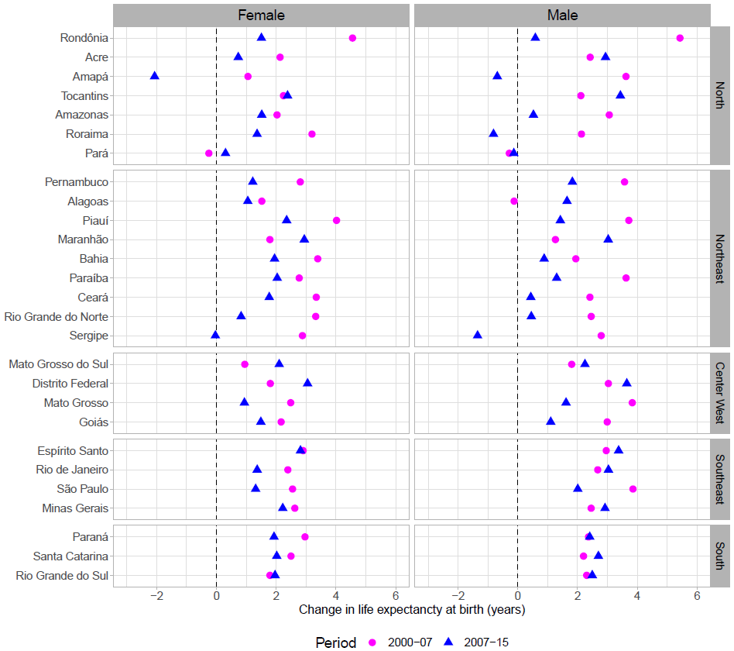

All states except one (Pará) experienced increases in life expectancy for females and males from 2000 to 2007 (Exhibit 1). From 2007 to 2015, female and male life expectancy increased at a lower pace in 75% and 60% of the sates, respectively. The magnitude of the slowdown in the latter period resulted in four states among males and one among females experiencing declines in life expectancy at birth. Despite the slowdown, all but two states (Amapá for females, and Pará and Sergipe for males) showed a continuous increase in life expectancy since 2000.

Exhibits 2-4 show how homicide, IHD, and causes amenable to medical service, respectively, contributed to changes in life expectancy at birth in the two periods 2000-07 and 2007-15. These are the causes of death from the amenable/avoidable mortality framework that contributed the most to changes in life expectancy at birth in both periods (for all causes of death, see Appendix Exhibits S1-S2).37

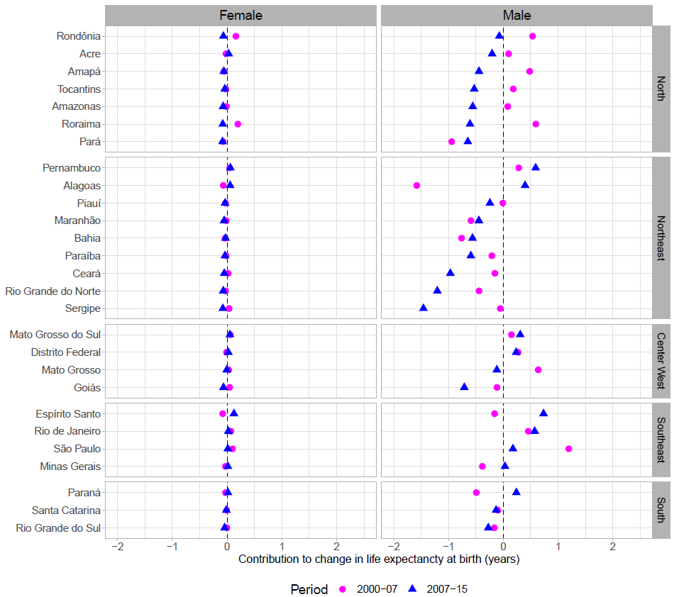

Exhibit 2 Changes In Life Expectancy At Birth In Brazil Related to Homicide Mortality, By State And Period, From 2000 To 2007 and From 2007 to 2015

Cause-specific mortality from homicide increased in 12 states among males in 2000-07 (Exhibit 2), leading to declines in life expectancy at birth over the period. One state experienced a decline in life expectancy of more than 1.5 years due to homicides. Moreover, in the period 2007-15 there was a clear worsening in several states related to increases in homicide mortality. In this period, 18 states (2 out of 3 states) experienced declines in life expectancy related to increases in violence. Three of these states lost one or more years of life expectancy at birth, while seven lost over six months. In fact, changes in mortality due to homicide caused the largest declines in life expectancy over the period 2000-15. The decline was most severe in least developed Northeast and North regions of Brazil, including the states of Sergipe, Rio Grande do Norte, Ceará and Pará. The impact of homicides was highly concentrated among males.

Mortality from IHD showed improvements in the period 2007-15 relative to 2000-07 among both females and males (Exhibit 3). Sixteen states for females, and 15 for males, experienced increases in mortality from IHD in the former period, leading to declines in life expectancy. In contrast, in the period 2007-15 most states increased their life expectancy as result of improvements in cause-specific mortality from IHD (21 and 19 for females and males, respectively).

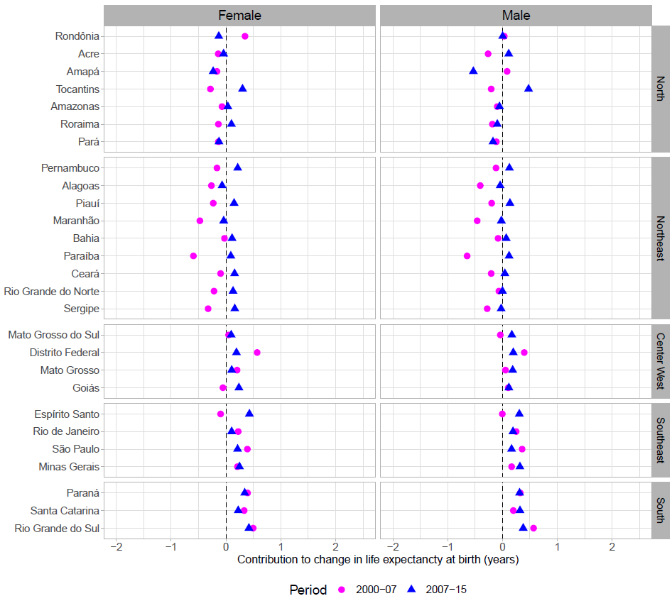

Figure 3 Changes In Life Expectancy At Birth In Brazil Related to Mortality resulting from Ischemic Heart Diseases, By State And Period, From 2000 To 2007 and From 2007 to 2015

Changes in mortality due to causes amenable to medical service, a priority of the Family Health Program, contributed to increasing life expectancy for most states in both periods, although two states showed declines in female life expectancy and negligible effect on male life expectancy between 2000 and 2007 (Exhibit 4). Notably, between 2000 and 2007, 13 states increased female life expectancy, and 12 for males, by more than one year due to medically amenable mortality below age 75. In the period, 2007-15 the improvements continued, although at a slower pace, and 18 and 23 states increased life expectancy by more than six months for females and males, respectively, as a result of declines in mortality from amenable causes to medical service. Similarly, changes in mortality due to remaining causes and death rates above age 75 also contributed to rising life expectancy in most states during the decade (see Appendix Exhibit S1-S2).37

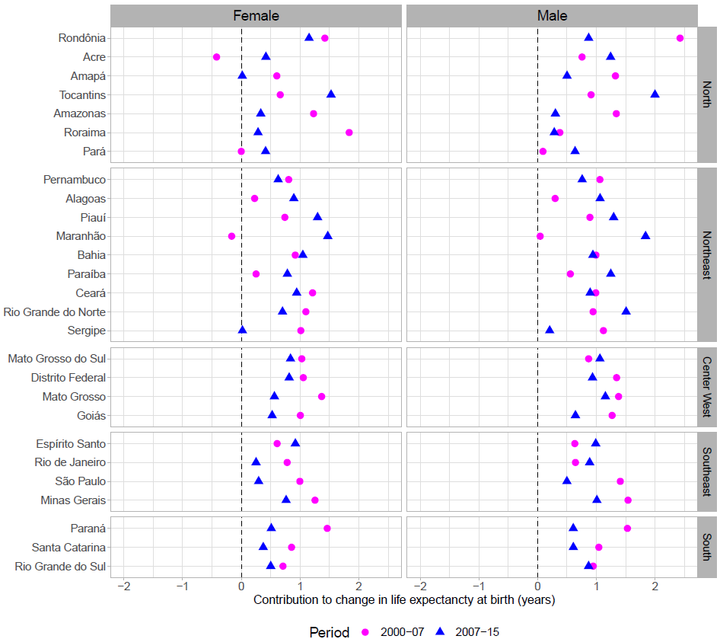

Figure 4 Changes In Life Expectancy At Birth In Brazil Related to Mortality resulting from Causes Amenable to Medical Service, By State And Period, From 2000 To 2007 and From 2007 to 2015

Although diabetes mortality had a smaller impact on changes in life expectancy relative to other causes of death over the period 2000-15, its impact was not negligible in some regions of Brazil. In the North and Northeast regions, the increase in diabetes mortality led to small decreases in life expectancy between 2000 and 2007, especially among females (Appendix Exhibit S2).37 That trend reversed and by 2007-15 only three states from the North region (Amapá, Amazonas and Pará) experienced decreases in female life expectancy. Among males, the impact of diabetes was smaller but also affected predominantly the Northern regions of Brazil (Appendix Exhibit S1).37

Contributions to changes in life expectancy due to alcoholic liver disease, HIV/AIDS, lung cancer, self-inflicted injuries and traffic accidents were negligible in these periods (Appendix Exhibits S1-S2).37

***Discussion [1200 words]***

**Trends in life expectancy at birth.** In Brazil from 2000 to 2015, life expectancy at birth increased from 71.5 years to 75.1 years.45 In this period, both females and males experienced a continuous increase in life expectancy, albeit at different levels. Our research sheds some light on this national trend by showing that improvements in life expectancy were unevenly shared across states in Brazil. State-specific changes in life expectancy at birth were driven by offsetting mortality trends. Improvements from medically amenable mortality and other causes of death were, in some cases, reversed by increased homicide, diabetes, and IHD mortality in the new century.

**Effect of homicides and amenable mortality on life expectancy at birth.** Our findings indicate that the large increases in homicide mortality, particularly in the Northern regions, have caused a downward trend in life expectancy improvements, which affected mainly males. Men in Latin America experienced disproportionate higher homicide rate than those of women.16 46 In fact, life expectancy among men in Brazil could be almost two years higher on average, if Brazilian men experienced the homicides rates of their counterparts in developed countries.3 The increase in homicide rates among males in the Northern regions is such that in 70% (11 out of 16) of the states in these regions male life expectancy decreased by six months or more in the period 2007-15.

Between 2000 and 2007 there were also increases in mortality from IHD, leading to decreased in life expectancy, mostly concentrated in states in the Northern regions. During this period diabetes mortality increased affecting females from states in the North. In contrast, improvements in mortality from IHD and diabetes led to increases in life expectancy among females and males in most states in Brazil from 2007 to 2015. This highlights the health inequities still present in Brazil. States in the North consistently show higher burden of disease than regions in the south.47

Our results clearly indicate that medically amenable mortality contributed significantly to increasing life expectancy throughout the entire period from 2000 to 2015. These findings highlight the relevance of public health care directed to prevention and control of complications from diseases, which were two of the main goals of the Family Health Program. Although in two states, Acre and Maranhão, mortality from amenable causes of death deteriorated between 2000 and 2007, these states recovered and improved life expectancy by reducing mortality in 2007-15. Consistent with our results, previous evidence suggests that improvements in primary health care has played an essential role in reducing deaths amenable to health care in Brazil.6 Similarly, our study highlights the need to strengthen healthcare in the Northern regions to further reduce mortality from IHD. Previous research argues that comprehensive and community-based health interventions can contribute to further decreased mortality from IHD in areas with high prevalence, such as Northern states of Brazil, through prevention, health care, and follow-up for heart diseases.9

**Violence in Brazil.** Homicides are unevenly shared across states in Brazil and they represent the main source of stalls in male life expectancy. The intensity and severity of the increase in homicide mortality is such that seven states from the Northeast and North regions (Ceará, Alagoas, Rio Grande do Norte, Bahia, Maranhão, Sergipe and Pará) lost over one year of life expectancy in the new century due to the increases in homicide mortality. To put this in perspective, these states host eight of the most dangerous cities in the world (Natal, Fortaleza, Belém, Feirá de Santana, Marceió, Vitória de Conquista, Salvador and Aracaju) with homicide rates over 47 deaths per 100,000 people.48 Other Latin American countries have reported similar results. For example, in Mexico the unprecedented rise of homicides related to the war on drugs has led to the stagnation of life expectancy at the national level between 2000 and 2010,23 with significant subnational variation.22 As a result, not only have life expectancy improvements slowed down, but also homicides have been identified as a determinant for health and lifespan inequalities.49 Our results argue for these detrimental consequences of violence on population health beyond mortality and decreases in life expectancy. For example, the mental health and perception of vulnerability in contexts of increasing homicide mortality are often unquantifiable and affect mainly women and children.50 Therefore, the health system should be prepared to a potential increase in mental health issues due to the insecurity felt by Brazilians, which is often overlooked by an inefficient and corrupt police, as well as by impunity and high crime rates in specific states.17 Our results therefore underscore the need of studies documenting the burden of violence on women and children’s health in Brazilian states.

Much homicides in Brazil are committed with firearms and are related to drug trafficking, and consumption of drugs and alcohol. Mortality rates from homicides are specially high for young males, between ages 15 and 50, as in other Latin American countries.3 Evidence from Brazil suggests that gun control measures can be effective to reduce the burden of violence on population health through specific legislations aiming at disarmament campaigns.51 While this has proven effective in some states, our findings make it clear that states from the North and Northeast regions need state-specific interventions. Specifically, implementing firearm control measures might be more challenging in these regions, relative to the rest of the country.51 Another key determinant for decreasing violence is reducing inequality. In Brazil, at the national level, homicide rates declined between 2001 and 2007, paralleling the decline in income inequality and a rise in income.25 Our results shed light on this trend by showing that the effect of homicides varies considerably across states. Poverty, social inequality and high capillarity of drug trafficking are important elements in violent states that sustain high levels of violent mortality.52-54

Moreover, evidence suggests that black males are at higher risk of being victims of violence.25 In 2007, 55% of the total homicides among males were among mixed race, while 8.2% were among black. However, we were not able to disentangle our results by ethnicity or socioeconomic status (SES) due to the lack of data. This highlights the need for accurate data on mortality from homicides and population estimates by ethnicity and SES to assess the different impact of homicides on life expectancy by population subgroups in Brazil.

**Addressing violence as a public health challenge.** Our results show that violence, through homicide, has had detrimental consequences on population health in Brazil. The Brazilian government has implemented several measures aiming at reducing violence in the country, such as Family Grant Program (*Programa Bolsa Família*), National Public Security Force (*Força Nacional de Segurança Pública*)ot the National Public Security Program (*Programa Nacional de Segurança Pública com Cidadania*).17 However, these strategies implemented by the government have produced mixed results regionally. For example, while some of these interventions coincided with a decline in homicide mortality at the national level, our results make it clear that in some regions, notably the North and Northeast, the increase in homicide has caused life expectancy losses since 2000. This period coincides with many of these interventions. Other approaches, such as conditional income transfer policies, educational policies and the strengthening of national labor market have shown favorable results in reducing poverty and alleviating social inequalities.

There is a need for increased attention and approach violence as a public health issue. During the health transition, the health care moved on from acute care to chronic care without incorporating violence as a dimension of health care. Latin American countries, including Brazil, are at present the region with the highest homicide rates globally.26 Homicide mortality in Latin American countries is independent of the epidemiological transition, since they are strongly associated with political instability, economic inequality, social segregation, and drug trafficking. We show that in Brazil there is a need for state-specific interventions to change the factors associated to cultural, economic and social conditions that contribute to violence.

**Conclusion [200]**

**References**

1. Palloni A, Souza L. The fragility of the future and the tug of the past: Longevity in Latin America and the Caribbean. *Demographic research* 2013;29:543.

2. World Health Organization. The world health report 2000: health systems: improving performance: World Health Organization 2000.

3. Canudas-Romo V, Aburto JM. Youth lost to homicides: disparities in survival in Latin America and the Caribbean. *BMJ global health* 2019;4(2):e001275.

4. World Health Organization. The world health report 2013: research for universal health coverage: World Health Organization 2014.

5. Nations U. World population prospects: the 2017 revision. *Population division of the department of economic and social affairs of the United Nations Secretariat, New York* 2017

6. Hone T, Rasella D, Barreto M, et al. Large reductions in amenable mortality associated with Brazil’s primary care expansion and strong health governance. *Health Affairs* 2017;36(1):149-58.

7. Macinko J, Dourado I, Aquino R, et al. Major expansion of primary care in Brazil linked to decline in unnecessary hospitalization. *Health Affairs* 2010;29(12):2149-60.

8. Macinko J, de Souza MdFM, Guanais FC, et al. Going to scale with community-based primary care: an analysis of the family health program and infant mortality in Brazil, 1999–2004. *Social science & medicine* 2007;65(10):2070-80.

9. Rasella D, Harhay MO, Pamponet ML, et al. Impact of primary health care on mortality from heart and cerebrovascular diseases in Brazil: a nationwide analysis of longitudinal data. *Bmj* 2014;349:g4014.

10. Rocha R, Soares RR. Evaluating the impact of community‐based health interventions: evidence from Brazil's Family Health Program. *Health Economics* 2010;19(S1):126-58.

11. Medici AC. Financiamento e contenção de custos nas políticas de saúde: tendências atuais e perspectivas futuras. *Planejamento e Políticas Públicas* 1990;4:83-98.

12. Paim J, Travassos C, Almeida C, et al. The Brazilian health system: history, advances, and challenges. *The Lancet* 2011;377(9779):1778-97.

13. Guanais FC, Macinko J. The health effects of decentralizing primary care in Brazil. *Health Affairs* 2009;28(4):1127-35.

14. Victora CG, Barreto ML, do Carmo Leal M, et al. Health conditions and health-policy innovations in Brazil: the way forward. *The Lancet* 2011;377(9782):2042-53.

15. Macinko J, Harris MJ. Brazil's family health strategy—delivering community-based primary care in a universal health system. *New England Journal of Medicine* 2015;372(23):2177-81.

16. Briceño-León R, Villaveces A, Concha-Eastman A. Understanding the uneven distribution of the incidence of homicide in Latin America. *International Journal of Epidemiology* 2008;37(4):751-57.

17. Reichenheim ME, De Souza ER, Moraes CL, et al. Violence and injuries in Brazil: the effect, progress made, and challenges ahead. *The Lancet* 2011;377(9781):1962-75.

18. Malta DC, Minayo MCdS, Soares Filho AM, et al. Mortalidade e anos de vida perdidos por violências interpessoais e autoprovocadas no Brasil e Estados: análise das estimativas do Estudo Carga Global de Doença, 1990 e 2015. *Revista Brasileira de Epidemiologia* 2017;20:142-56.

19. Messias E. Income inequality, illiteracy rate, and life expectancy in Brazil. *American Journal of Public Health* 2003;93(8):1294-96.

20. Borges GM. Health transition in Brazil: regional variations and divergence/convergence in mortality. *Cadernos de saude publica* 2017;33(8)

21. Gamlin J. Violence and homicide in Mexico: a global health issue. *The Lancet* 2015;385(9968):605-06.

22. Aburto JM, Beltrán-Sánchez H, García-Guerrero VM, et al. Homicides in Mexico reversed life expectancy gains for men and slowed them for women, 2000–10. *Health Affairs* 2016;35(1):88-95.

23. Canudas-Romo V, García-Guerrero VM, Echarri-Cánovas CJ. The stagnation of the Mexican male life expectancy in the first decade of the 21st century: the impact of homicides and diabetes mellitus. *J Epidemiol Community Health* 2015;69(1):28-34.

24. García J, Aburto JM. The impact of violence on Venezuelan life expectancy and lifespan inequality. *International journal of epidemiology* 2019

25. Murray J, de Castro Cerqueira DR, Kahn T. Crime and violence in Brazil: Systematic review of time trends, prevalence rates and risk factors. *Aggression and Violent Behavior* 2013;18(5):471-83.

26. United Nations Office on Drugs and Crime. Global study on homicide 2013: trends, contexts, data: UNODC 2013.

27. Ministry of Health in Brazil. System of Mortality Information <www.datasus.gov.br2017> [

28. Queiroz BL, Freire FHMdA, Gonzaga MR, et al. Completeness of death-count coverage and adult mortality (45q15) for Brazilian states from 1980 to 2010. *Revista Brasileira de Epidemiologia* 2017;20:21-33.

29. Agostinho CS, Queiroz BL. Estimativas da cobertura do registro de óbitos para Unidades da Federação, Brasil 2000. *Anais* 2016:1-21.

30. Queiroz BL. Estimativas do Grau de Cobertura e da Esperança de Vida para as Unidades da Federação no Brasil entre 2000 e 2010. *Anais do XVIII Encontro de Estudos de População da ABEP* 2012:19-23.

31. Brazilian National Statistics Office. Population Projections. <https://www.ibge.gov.br/estatisticas-novoportal/sociais/populacao/9103-estimativas-de-populacao.html2017>.

32. Nolte E, McKee CM. Measuring the health of nations: updating an earlier analysis. *Health affairs* 2008;27(1):58-71.

33. Nolte E, McKee M. Does health care save lives? Avoidable mortality revisited: The Nuffield Trust 2004.

34. Beltrán-Sánchez H. Avoidable mortality. International handbook of adult mortality: Springer 2011:491-508.

35. Elo IT, Beltrán-Sánchez H, Macinko J. The contribution of health care and other interventions to black–white disparities in life expectancy, 1980–2007. *Population research and policy review* 2014;33(1):97-126.

36. Malta DC, Sardinha L, Moura Ld, et al. Atualização da lista de causas de mortes evitáveis por intervenções do Sistema Único de Saúde do Brasil. *Epidemiologia e Serviços de Saúde* 2010;19(2):173-76.

37. Appendix. Supplemental material for the paper on homicide and life expectancy in Brazil.2019.

38. de Almeida-Pititto B, Dias ML, de Moraes ACF, et al. Type 2 diabetes in Brazil: epidemiology and management. *Diabetes, metabolic syndrome and obesity: targets and therapy* 2015;8:17.

39. Botega NJ, Garcia LdSL. Brazil: the need for violence (including suicide) prevention. *World psychiatry* 2004;3(3):157.

40. Rosenberg HM. Cause of death as a contemporary problem. *Journal of the history of medicine and allied sciences* 1999;54(2):133-53.

41. Guralnick L. Some problems in the use of multiple causes of death. *Journal of Chronic Diseases* 1966;19(9):979-90.

42. Preston S, Heuveline P, Guillot M. Demography: measuring and modeling population processes. 2000

43. Horiuchi S, Wilmoth JR, Pletcher SD. A decomposition method based on a model of continuous change. *Demography* 2008;45(4):785-801.

44. OPS. Situacion de salud en las Americas: indicadores basicos 2000: OPS (Organizacion Panamericana de la Salud) 2000.

45. Institute for Health Metrics and Evaluation. GBD Foresight: IHME; 2019 [Available from: <https://vizhub.healthdata.org/gbd-foresight/>.

46. Beato Filho CC, Marinho FC. Padrões regionais de homicídios no Brasil. *Homicídios no Brasil Rio de Janeiro: FGV* 2007:177-90.

47. Marinho F, de Azeredo Passos VM, Malta DC, et al. Burden of disease in Brazil, 1990–2016: a systematic subnational analysis for the Global Burden of Disease Study 2016. *The Lancet* 2018;392(10149):760-75.

48. Consejo Ciudadano para la Segfuridad Pública y la Justicia Penal. Las 50 ciduades más violentas del mundo 2018 [The 50 most dangerous cities in the worl 2018]: Seguridad, Justicia y Paz; 2019 [Available from: <http://www.seguridadjusticiaypaz.org.mx/seguridad/1567-estudio-las-50-ciudades-mas-violentas-del-mundo-2018>.

49. Aburto JM, Beltrán-Sánchez H. Upsurge of homicides and its impact on life expectancy and life span inequality in Mexico, 2005–2015. *American journal of public health* 2019;109(3):483-89.

50. Canudas-Romo V, Aburto JM, García-Guerrero VM, et al. Mexico's epidemic of violence and its public health significance on average length of life. *J Epidemiol Community Health* 2017;71(2):188-93.

51. de Fatima Marinho de Souza M, Macinko J, Alencar AP, et al. Reductions in firearm-related mortality and hospitalizations in Brazil after gun control. *Health Affairs* 2007;26(2):575-84.

52. Souza G, Magalhães F, Gama I, et al. Determinantes sociais e sua interferência nas taxas de homicídio em uma metrópole do Nordeste brasileiro. *Rev Bras Epidemiol Suppl DSS* 2014:194-203.

53. Waiselfisz JJ. HOMICÍDIOS POR ARMAS DE FOGO NO BRASIL. *Mapa da Violência* 2016

54. Wanzinack C, Signorelli MC, Reis C. Homicides and socio-environmental determinants of health in Brazil: a systematic literature review. *Cadernos de saude publica* 2018;34:e00012818.